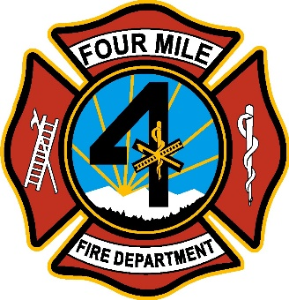
Four Mile Fire Protection District
Special Board Meeting for the Board of Directors
June 8, 2022

Effective May 25, 2022, we will no longer entertain comments from the public during the board meeting. Public comments will be welcomed near the end of the meeting just as your agenda indicates. Each individual will be given 3 minutes to speak. If we are unable to answer your question, it will be answered at the next board meeting.

notice is hereby given that a Special Board Meeting for the Board of Directors of the Four Mile Fire Protection District will be held at 8437 Teller County Rd 11, Florissant, Colorado 80816, on Wednesday, June 8, 2022, at 5:00 p.m.

Agenda

- Call to Order
- Roll Call to Establish Quorum
- Discuss expenditures for July 2nd BBQ
- Discuss purchase of wildland vehicle
- Adjourn

This meeting is open to the public.

