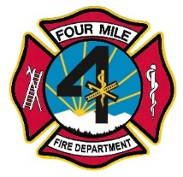 Four Mile Fire Protection District
Regular Meeting of the Board of Directors

February 15, 2023

Notice is hereby given that a regular meeting of the Board of Directors of the Four Mile Fire Protection District will be held at 8437 Teller County Road 11, Florissant, Colorado 80816, on Wednesday, February 15, 2022, at 7:00 p.m.

Effective May 25, 2022, we will no longer entertain comments from the public during the board meetings. Public comments will be welcomed near the end of the meeting just as your agenda indicates. Everyone will be given 3 minutes to speak. If we are unable to answer your question, it will be answered at the next board meeting.

Agenda
- Call to Order_________
  - Roll call for quorum.
- Previous Minutes – 1/18/2023
- Treasurer’s Report
  - Vote to approve January financials.
- Old Business
  - Website update
- New Business:
  - Emergency hose purchase – Ratify vote by email
  - Medical Waste
  - Please vote on Four Mile Paying for Chief’s cell phone
  - Accounting Housekeeping. Shop around for prices, plan ahead
  - POV issues
  - Application for exemption from audit and hiring Erickson, Brown & Kloster for Compilation.
  - Drone school - shouldn’t we send two people?
- Chief’s Report:
- Donations:
- Other issues :
- Public Comment:
- Adjournment at _________________________

